+91 7905084258
rs04863@gmail.comLinkedIn NEW DELHI

RUPESH KUMAR TECHNOLOGY ANALYST
TATA Consultancy Service

SUMMARY

5 years of Experience in Mainframe Support Scheduling and Development.
  - years of Experience in Data cleaning, preprocessing and Datamodeling.

PROFESSIONAL EXPERIENCE
S

DTCC(EPSMainframe) Sep’20-Jun’22
Technology Worked: - JCL, COBOL, DB2, UNIX.
Tools Worked: - CA Scheduler, Autosys.
The Project focused to support the DTCC Application and Alerts at L2 Level.
Responsibilities: -
    - Resolved the Mainframe Abend and provided the solution and root cause withinSLA.
    - Processed the Daily User Request ofAutosys.
    - Processed the SOD of Application using UNIX/LINUX Server.
    - Performed the weekly shutdown of Mainframe Environment (PROD, PILOT, QA, DEV) and bring them upusing Console.
    - Checkouts Performed.
    - Created Daily BusinessReport.

DTCC(DNA) Mar’20 -Sep’20
Technology Worked: - Python, SQL Package:- NumPy, Pandas, Matplotlib.
Roles and Responsibilities: - Goal is to track the dumping pattern for the products based on their historical data.

Description: - Dataset was provided with the details of various Products country wise, Price, Quantity etc. Analyze, understand, and visualize the data using various chart and choose only important data for Data model building, handle missing valuess, created the reports and dashboards.
    - Data cleaning anddata-preprocessing.
    - Experience in writing query using tools SQL Server and Python Scripting (lib: - Pandas, NumPy, Matplotlib, Seaborn)
    - Responsible for extracting insight from the Taxdata.• Databaseconcepts.

DTCC(DBA) Nov ‘19-Mar’20
Technology Worked: - Python, SQL Package: - NumPy, Pandas, Matplotlib.
Responsibilities: -
    - Write the Query to perform Checkouts/UserRequest.
    - Data cleaning and data pre-processing and data visualization and data modelling usingPandas.
    - Expertise in Writing query using SQLServer.• DatabaseConcept.

INGGMFCL:- Mar’18-Nov’19
Technology Worked: - JCL, COBOL, CICS, PowerShell, SQL. Tools Worked: -Micro Focus.
IDE: - Visual Studio, SQL Server Management Studio.

Objective: - The Project focused on to Migrate Mainframe code to Windows Compatible code using MicroFocus Tool.
Responsibilities: -
    - Developed and Tested the code which was written in AS400(CL/RPG) to Windows Compatible code byusing Micro FocusTool.
    - Rewritten the code and ensure faster execution of code using PowerShell and COBOL compatibleAPI.
    - Plugins to Server for Microfocus Tool and SQL Server Management Studio.

MSSB(BatchOps):- Oct’17-Mar’18
Technology Worked: - JCL, COBOL, SQL.
Objective: - The Project focus was on batch and Alerts monitoring for Banking Application. Responsibilities: -
    - Monitored the production Batch and ensuring the SLA is not impacted, provided the fix for any job failureroot cause analysis ProblemManagement.
    - Alert Monitoring andAutomation.
    - Interacted with Daily Business User sand resolved theirqueries.• Checkouts performed onDifferent application.

Jun’16-Oct’17
MSSB(GBT-CM): -
Technology Worked: - JCL, COBOL. Responsibilities: -
    - Solved Mainframe Abends within SLA.
    - Created Daily BusinessReport.
    - Solved the Data Requests and FA’s Queries.
    - Worked on Report Automation to reduce manualeffort.
    - Handled Incident Management process for application outage and criticalissues.
    - Interacted with the Daily Business Users and resolved thequeries.
AmericanExpress:- Mar’16-Jun’16
Technology Worked: - JCL
Responsibilities: -
    - Created Technical documentation such as technical understanding document and code comment usingJCL.

InfosysTraining:- Sep’15-Mar’16
Project: -

INFY MF BANKINGONLINE FLIGHTBOOKING

EDUCATION

B.Tech Intermediate Matriculation
NIT Warangal CGPA:- 6.25/10
Jun’11-May’15
B.B.N CollegePercentage: - 60/100Mar’08-Mar’10
Railway Pravesika Vidayalaya Percentage: - 71/100
March 2008

KEY SKILLS
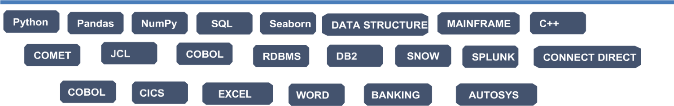

CERTIFICATION

Infosys Certified Python Programmer. Infosys Certified Mainframe Programmer. Infosys Certified Cobol Programmer.
Financial Security.
Finacle.
Infosys Certified SQL and Database Professional. Infosys Certified Python Associate.
Infosys Certified ITIL Foundation Associate. Python for Data Science (Udemy).

AWARDS & RECOGNITION

- Infosys Mentor Award,2018
- Infosys SpotAward,2019
- Infosys Spot Award2020.

